# EARLY DETECTION OF FOREST FIRE USING DEEP LEARNING IMAGE PRE-PROCESSING

**APPLYING ImageDataGenerator to train and test dataset**

|  |  |
| --- | --- |
| Team ID | PNT2022TMID39009 |
| Project Name | Project-Early detection of forest fire using deep learning |

The ImageDataGenerator class has three methods, 1.flow ( ),

1. flow_from_directory ( )
2. flow_from_dataframe ( ) to read the images from a big numpy array and folders containing images.

flow_from_directory ( ) expects at least one directory under the given directory path.

# APPLYING ImageDataGenerator to train dataset:

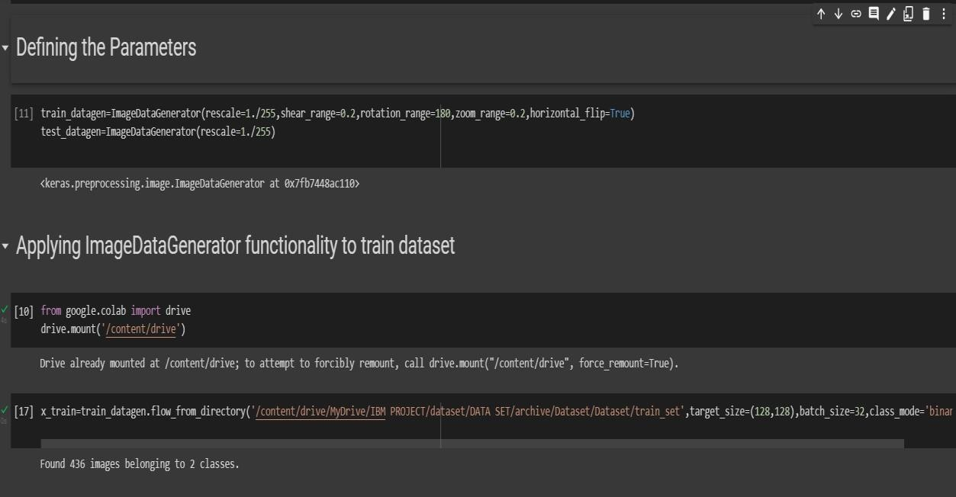ply**flow_from_directory ( )**methodfor Train folder.

# APPLYING ImageDataGenerator to test dataset:

Applying the **flow_from_directory ( )** methodfortest folder.

